Predictive Analsis

We will build a pipeline to with a model that can predict the landing od falcon 9.

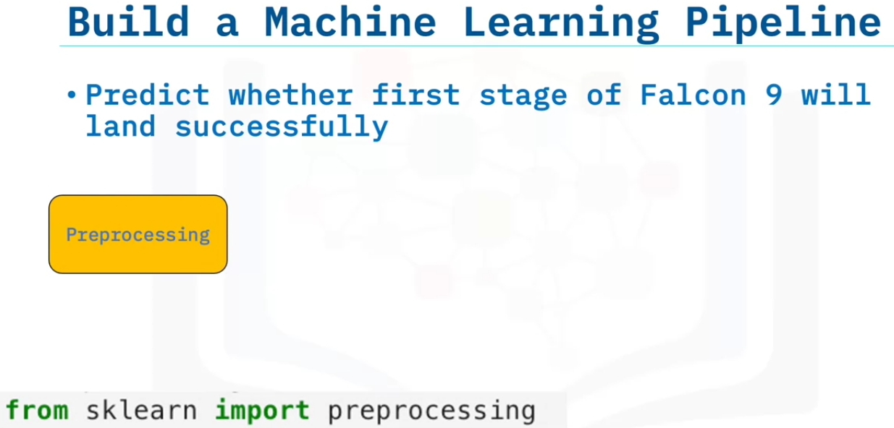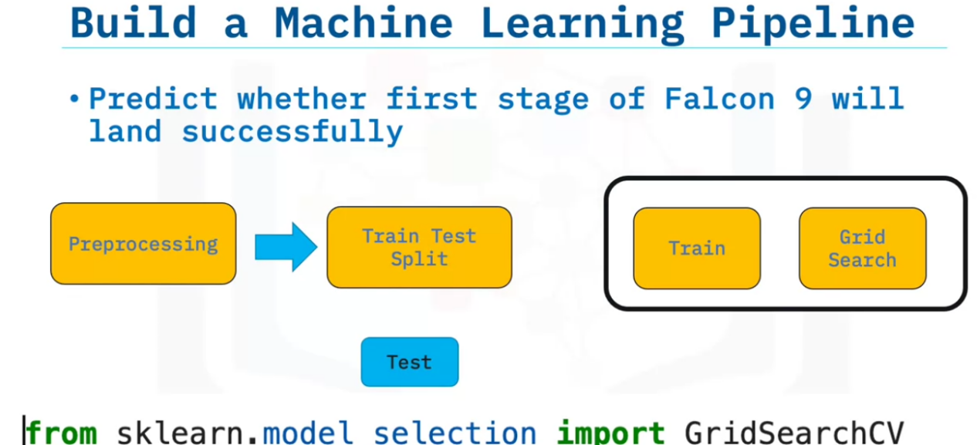

we wil perform preprocessing, then we will use traintest split. Then we use the gridSearch for hyper parameter tuning.

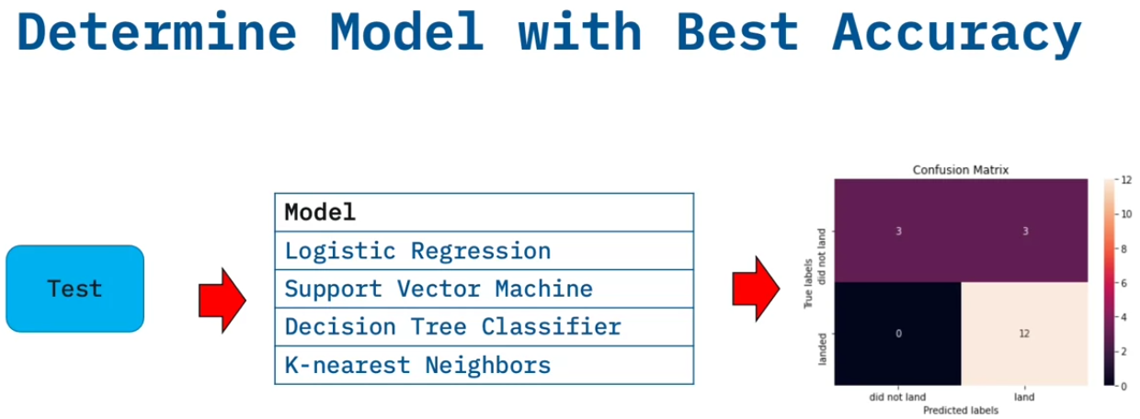

Then we find the best accuracy. We will build the above model and display the confusion matrix.